IOWA

Universal CTE Standards

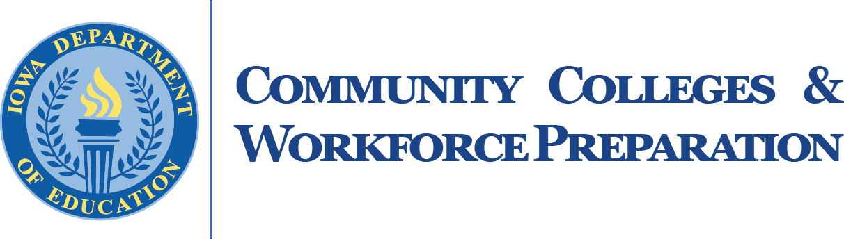
BUSINESS, MANAGEMENT & ADMINISTRATION • AGRICULTURE, FOOD & NATURAL RESOURCES • INFORMATION SOLUTIONS • APPLIED SCIENCES, TECHNOLOGY, ENGINEERING &MANUFACTURING • HEALTH SCIENCES • HUMAN SERVICE S

Iowa's Career and Technical Education (CTE) is organized around six service areas and aligned with the national Career Clusters Framework:

- Agriculture, Food and Natural Resources
- Applied Sciences, Technology, Engineering and Manufacturing
- Business, Finance, Marketing and Management
- Health Science

Human Services and Family and Consumer Sciences

Information Solutions

Career pathway programs in each of the identified service areas integrate technical and academic knowledge and skill development with work-based learning experiences to better prepare students to succeed in college and careers. The Universal Standards are common to all of the six pathways in Iowa's six CTE service areas and include competencies to help students explore various career options and prepare students to be good employees.

This document lists the Iowa Universal Core Standards with a crosswalk to Iowa K-12 21st Century Skills.*

*Published 2019

Iowa CTE Universal Core Standards and Iowa K-12 21st Century Skills
Universal Core Career and Technical Education Standards |  | 21st Century
U-1 | Employability Skills
U-1.1 | Demonstrate transferable knowledge, attitudes and technical and employability skills in school, community and workplace settings. | ES.3
U-1.2 | Demonstrate job seeking and job keeping skills. | ES.2
U-1.3 | Demonstrate employability skills, work ethics and professionalism. | ES.4, ES.5
U-1.4 | Demonstrate teamwork and leadership skills in the family, workplace and community. | ES.1, ES.2
U-1.5 | Create an environment that encourages and respects the ideas, perspectives and contributions of all group members. | ES.2, CL.2
U-2 | Career Pathways
U-2.1 | Analyze career paths within industries. | ES.4
U-2.2 | Explain roles and functions of individuals engaged in related careers. | ES.2
U-2.3 | Analyze opportunities for employment and entrepreneurial endeavors. | ES.4
U-2.4 | Summarize education and training requirements and opportunities for career paths. | ES.4
U-2.5 | Analyze the role of professional organizations, credentials, certifications and degrees in related careers. | ES.4, ES.5, CL.1
U-2.6 | Analyze potential career choices to determine the knowledge, skills, attitudes and opportunities associated with each career. | ES.4
U-3 | Industry Impact on Society
U-3.1 | Analyze the impact of the industry on local, state, national and global economies. | TL.1, ES.2
U-3.2 | Examine how the industry improves society. | TL.3, TL.4
U-3.3 | Identify how the industry and related technology impacts individuals, society and the environment. | TL.1, TL.4
U-3.4 | Evaluate the effects of technology on individual and family resources in a global context. | ES.3, TL.4

Universal Core Career and Technical Education Standards |  | 21st Century
U-4 | Safety in the Industry
U-4.1 | Demonstrate safety and sanitation procedures for a clean and safe environment. | HL.5, CL.1
U-4.2 | Summarize federal and state regulations regarding safe handling, usage and storage of chemicals. | HL.1
U-4.3 | Apply Occupational Safety and Health Administration (OSHA) regulations to safety procedures for the industry. | HL.2
U-4.4 | Apply safety and security procedures as required by Hazard Analysis and Critical Control Point (HACCP), Occupational Safety and Health Administrations (OSHA) and other agencies. | HL.2, CL.1
U-4.5 | Students apply safety practices in the lab and on worksites. | HL.3, CL.1
U-4.6 | Demonstrate safe practices and procedures with tools and equipment. | HL.3, CL.1
U-4.7 | Demonstrate appropriate use of personal protective equipment. | HL.3, CL.1
U-4.8 | Document safety concerns according to local policies and procedures. | HL.4, CL.1
U-5 | Ethics in the Workplace
U-5.1 | Analyze state and federal policies and laws providing consumer protection. | ES.2
U-5.2 | Utilize sound decision-making principles. | ES.4
U-5.3 | Model ethical behavior in the classroom and workplace setting. | ES.3

Iowa K-12 21st Century Skills and Iowa CTE Universal Core Standards
Iowa K-12 21st Century Skills |  | CTE Universal Core Standards
ES | Employability Skills
ES.1 | Communicate and work productively with others, incorporating different perspectives and cross-cultural understanding, to increase innovation and the quality of work. | U-1.4
ES.2 | Adapt to various roles and responsibilities and work flexibly in climates of ambiguity and changing priorities. | U-1.2, U-1.4, U-  1.5, U-2.2, U-3.1, U-5.1
ES.3 | Demonstrate leadership skills, integrity, ethical behavior and social responsibility while collaborating to achieve common goals. | U-1.1, U-5.3, U- 5.7
ES.4 | Demonstrate initiative and self–direction through high achievement and lifelong learning while exploring the ways individual talents and skills can be used for productive outcomes in personal and professional life. | U-2.1, U-2.3, U-  2.4, U-2.5, U-  2.6, U-5.2
ES.5 | Demonstrate productivity and accountability by meeting high expectations. | U-2.5
HL | Health Literacy
HL.1 | Demonstrate functional health literacy skills to obtain, interpret, understand and use basic health concepts to enhance personal, family and community health. | U-4.2
HL.2 | Synthesize interactive literacy and social skills to establish  and monitor personal, family and community goals related to all aspects of health. | U-4.3, U-4.4
HL.3 | Apply critical literacy/thinking skills related to personal, family and community wellness. | U-4.5, U-4.6, U- 4.7
HL.4 | Use media literacy skills to analyze media and other influences  to effectively manage health risk situations and advocate for self and others. | U-4.8
HL.5 | Demonstrate behaviors that foster healthy, active lifestyles for individuals and the benefit of society. | U-4.1

Iowa K-12 21st Century Skills |  | CTE Universal Core Standards
TL | Technology Literacy
TL.1 | Demonstrate creative thinking, construct knowledge and develop innovative products and processes using technology. | U-3.1, U-3.3
TL.2 | Use digital media and environments to communicate and work collaboratively, including at a distance, to support individual learning and contribute to the learning of others.
TL.3 | Apply digital tools to gather, evaluate and use information. | U-3.2
TL.4 | Demonstrate critical thinking skills using appropriate tools and resources to plan and conduct research, manage projects, solve problems and make informed decisions. | U-3.3, U-  3.4
CL | Civil Literacy
CL.1 | Analyze civic and political institutions. | U-2.5
CL.2 | Apply civic virtues and democratic principles. | U-1.5
CL.3 | Interpret processes, rules and laws. | U-4.1, U-4.4, U-  4.5, U-4.6, U-  4.7, U-4.8

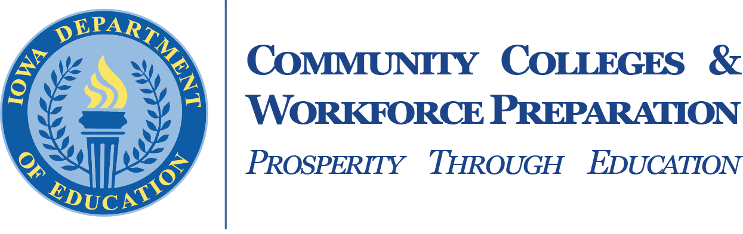

www. educateiowa. gov /ccpublications

The Division of Community Colleges and Workforce Preparation within the Iowa Department of Education administers a variety of diverse programs that enhance Iowa’s educational system and help to prepare a skilled and knowledgeable workforce. Divided between two bureaus — the Bureau of Community Colleges and the Bureau of Career and Technical Education — the Division is committed to providing and supporting opportunities for lifelong learning. In addition to working with Iowa’s 15 public community colleges on state accreditation, program approval, equity review, and data reporting, guidance is also provided in the areas of career and technical education, workforce training and economic development, adult education and literacy, military education, the state mandated OWI education program, the GAP Tuition and PACE programs, Senior Year Plus and the Statewide Intermediary Network program.

