Iowa Department of Education logoIowa Department of Education Guidance

**Version 3.0, Release Date: 1/23/2019**

Statewide School-Level Reporting

Financial Coding Practices

The Elementary and Secondary Education Act of 1965, as amended by the Every Student Succeeds Act (ESSA), requires all state education agencies to report “per pupil expenditures of Federal, State, and local funds, including actual personnel expenditures and actual nonpersonnel expenditures of Federal, State, and local funds, disaggregated by source of funds, for each local educational agency and each school in the State for the preceding fiscal year,” (SEC 1111(h)(1)(C)(x)). Additionally, the state must ensure each local education agency collects the appropriate data and provides this information in their annual report (SEC 1111(h)(2)(C)).

ESSA requirements necessitate a change to some dimension codes within the Iowa Chart of Account Coding. Effective with the fiscal year beginning July 1, 2018, the updated coding will be used for reporting district financial information in the Certified Annual Report (CAR). The state of Iowa’s federal accountability system will be supported by this elevated focus on school-level financial transparency.

The practices for state reporting contained herein are provided to assist in meeting this requirement. These practices were derived through a joint effort of the Iowa Department of Education (Department) and the Department-convened School-Level Reporting Advisory group (SLR Advisory). The SLR Advisory is comprised of school business officials from small, medium, and large districts with representation across all area education agencies (AEAs) in Iowa.

**New to Version 3 (V3):** The release of Version 2 (V2) last October provided an opportunity for another dozen conversations around the state as well as continued conversations with the SLR Advisory. Additionally, The National Center for Education Statistics (NCES), a part of the U.S. Department of Education, released an expanded list of functions that are required to be reported at the school level. There is an expectation that school-level expenditures for these identified functions be included in FY19 (NCES references FY18, but that is not possible for Iowa). The Department does realize FY19 is nearly half completed, but would appreciate the districts’ efforts to include these newly identified functions for the current reporting period.

The Department has updated this practices document to reflect the newly identified functions. Additionally, the Department continues its charge from the districts to support district-to-district coding consistency while supporting a reasonable level of coding flexibility. Below are the items that have been added to version (V3).

* Standard Practices (Funds and Functions, page 2)
  + The list of functions required to be reported at the school level has been updated.
  + Version 1 required functions: 1000, 21XX, 22XX, and 24XX
  + Version 3 added functions: 23XX, 25XX, 26XX, 27XX, 31XX, and 32XX
* Best Practices (page 5)
  + Best practices #4, #5, #6, and #7 have been added.
* Appendix A: Funds and Functions (pages 8-11)
  + The Funds Table has been updated to identify additional funds that commonly have expenditures that require “Standard Practice (SP) School Coding” which now considers the newly required functions.
  + The Functions Table has been updated to reflect the newly identified functions as “Required School Coding”.

# Definitions

*Standard Practice*: Items identified as a “standard practice” are practices that will be adopted statewide with minimal exceptions. If the standard practice is for an expenditure/expense to be coded to the district level, it is permissible for the expenditure/expense to be coded at the school level as some Functions may move to school level in future years.

*Best Practice*: Items identified as a “best practice” are practices that are encouraged to be adopted where possible and when applicable.

*District Practice*: Items identified as a “district practice” are practices that a district will determine whether to code the expenditure/expense to the district or to the school level. This also includes any items not yet specifically listed as a standard or best practice.

*State Assignment:* Items identified as “state assignment” are those coded to certain dimensions for which inclusion and placement on the report card will be decided by the state. These items have no impact on the district’s coding practice as the placement will be made after the CAR upload.

*State Assignment*: *District Level* (allocated) –These identified expenditures will be allocated in the same manner as district level expenditures for the per pupil expenditure (PPE) calculation, regardless of the facility code used by the district.

*State Assignment*: *District Only* (unallocated)– These identified expenditures will be included in the district only lump sum amount and will not be allocated as part of the PPE calculation, regardless of the facility code used by the district.

*State Assignment*: *Exclusion* – These identified expenditures will not appear on the report card.

# Standard Practices

Guidance shared as a standard practice will be adopted statewide with minimal exceptions. If the standard practice is for an expenditure/expense to be coded to the district level (allocated), it is permissible for the expenditure/expense to be coded at the school level as some Functions may move to school level in future years.

## Functions and Funds

Expenditures for Functions 1000-2799, 31XX, and 32XX are to be coded to the school level whenever possible. The expenditures for other Functions coded to the school level will be reflected at the school level in the report card unless otherwise identified as a State Assignment (See State Assignments.) Coding expenditures/expenses within these Functions for specific Funds should be handled as described in Appendix A: Funds and Functions Table.

## Facility Dimension

A set of standard practices has been developed for use of the Facility Dimension within the [Iowa Chart of Account Coding](https://www.educateiowa.gov/documents/uniform-financial-accounting/2013/04/iowa-chart-account-coding) document. Facility codes for public schools can be found in the [Department Directory](https://www.educateiowa.gov/directories). Facility codes for public schools and SWVPP community partners can be found in the [Iowa Education Portal](https://portal.ed.iowa.gov/iowalandingpage/Landing.aspx) and in the School Information Update application.

1. The facility code must be used to identify schools.
2. The school facility code used must match the BEDS code, unless otherwise noted.
3. District level (allocated) expenditures will be coded to 0000 or 9XXX, unless otherwise noted. Refer to District Practices.

## Employee Coding

Procedures for coding all employees have been established.

1. If a district is able to code an employee’s salary and benefits directly to a school, do so.
   1. If an individual serves multiple schools, review the contract or planned work schedule and decide if an appropriate split can be determined. If so, code the split to each school.
   2. If an appropriate split cannot be determined, consider whether the individual could be assigned to a specific school instructional level for later allocation (example: Learning Technologies Coordinator serving all elementary schools). Refer to District Practices.
2. If unable to do so, or if an individual serves all schools regardless of instructional level, code to the district level for later districtwide allocation by the state.

## Expenditure Reporting Type Considerations

There are five different ways an expenditure can be considered within the school-level per pupil expenditure calculation: (1) school level, (2) school instructional level (allocated), (3) district level (allocated), (4) district only (unallocated), and (5) exclusion*. The following illustration visually reflects how each will be included in the report card.

| **Direct Coding Type** | **Example** | **Use** |
| --- | --- | --- |
| (1) School level | Teacher Salary | Expenditure specific to a school (e.g., Hillcrest Elementary) |
| + | Cell intentionally left blank. | Cell intentionally left blank. |
| (2) School instructional level | Professional Development for all elementary school teachers | Expenditure allocated proportionately across all elementary schools (allocated at appropriate school instructional level based on designated code selected) |
| + | Cell intentionally left blank. | Cell intentionally left blank. |
| (3) District level | Superintendent Salary | Expenditure allocated proportionately across all schools (e.g., all schools within Weaver School District) |
| = | Cell intentionally left blank. | Cell intentionally left blank. |
| Per Pupil Expenditure | Blank | ESSA required calculation |
| Cell intentionally left blank. | Cell intentionally left blank. | Cell intentionally left blank. |
| (4) District only | Construction | Not included in ESSA per pupil expenditure calculation, but still shown |
| Cell intentionally left blank. | Cell intentionally left blank. | Cell intentionally left blank. |
| (5) Exclusion* | Agency Fund | Not included in calculation, not shown |

* Exclusions will not be determined by facility code.

## State Assignments

After the CAR upload process is complete, the Department will assign certain expenditures for placement into specific report card categories (district level, district only, or exclusions). These assignments will occur regardless of the facility code used by the district; therefore, districts maintain flexibility to support their local coding preferences. The State Assignments are provided in the following table. The table helps to (1) define the reason for the assignment (Guiding Principle), (2) recognize the category on the report card to which the expenditure will be assigned (State Assignment Type), and (3) identify the associated dimensions that will be used to assign the expenditures (Coding Dimension).

| Guiding Principle | State Assignment Type | Coding Dimension |
| --- | --- | --- |
| Causes PPE fluctuation | District Level | AEA Flow through – Function 6100, Object 961  Management Fund – Fund 22 |
| Causes PPE fluctuation | District Only | Facilities, Acquisition, and Construction – Function 4XXX |
| Expenditures for students outside Average Daily Membership (ADM) | District Only | Home School Assistance Program (HSAP) – Project 1113  Nonpublic – Program 5XX  Tuition – Object 562-564, 567-569 |
| Expenditures not related to PK-12 | Exclusion | Community Service Enterprise – Funds 65-67  Trust Funds – Funds 8X  Agency Funds – Funds 9X (FY20) |
| Expenditures captured elsewhere or in prior years | Exclusion | Interfund Transfer – Function 62XX, Object 91X  Debt Service – Object 831, 92X  Internal Service Funds – Fund 7X  Intrafund Transfers – Object 95X |

## Special Population Expenditures

The procedure for coding expenditures for special populations of students is as follows: where possible, expenditures are coded to the school where the student is served, their attendance is tracked, and their assessment information is aggregated. Refer to Appendix B: Accountability and Financial Coding Matrix. The Accountability columns of the matrix illustrate the district accountable for the (1) assessment score and (2) ADM value. The expenditures then should be coded accordingly at (1) the serving district and (2) the resident district as shown in the Recommended Expenditure Coding columns. See Appendix C: How to Use the Accountability and Financial Coding Matrix for additional explanation.

Statewide Voluntary Preschool Program (SWVPP)

Expenditures for the Statewide Voluntary Preschool Program will be included as part of the district’s report card. Districts should be (1) reporting daily attendance, (2) tracking adds and drops daily, and (3) providing an accurate full-time equivalent (FTE) value according to definitions provided in the [SRI Data Dictionary.](https://educateiowa.gov/documents/student-reporting-iowa/2017/08/sri-data-dictionary-2017-2018-condensed) The district should have practices in place to collect and record this information in the Student Information System.

Daily attendance, additions, and drops are required in order to generate an accurate ADM value. An enrollment day value is “1” regardless if the student is a half-time or full-time student. The FTE is calculated based on the percent of the day attended per week (10 minimum hours) compared to a normal elementary school week. If a student has an FTE greater than zero (0), there must be a value entered for days enrolled.

Sample Preschool FTE Calculations

| Number of Days Per Week | Length of Day | FTE Calculation |
| --- | --- | --- |
| 5 | Half Day | 0.50 |
| 3 | Full Day | 0.60 |
| 5 | Full Day | 1.00 |

# Best Practices

These practices should be adopted where possible and when applicable. Best practices are directed toward districts for which the items are relevant; not all best practices will be applicable to each district.

1. Districts may assign Home School Assistance Program (HSAP) expenditures to a new statewide facility code, 0031.
2. Beyond normal staff coding procedures (see Employee Coding), a district may choose to periodically (i.e., each year, semester, or quarter) evaluate student rosters for special education teachers to determine where the teacher’s time is actually spent. This is a best practice for districts that historically find teachers serving different populations or different locations throughout the school year.
3. If a district shares an employee with another district, the percentage of the employee’s time that is served in the district will be coded as normal and the remaining percentage (percent shared) will be coded to a district only facility code.
   1. Example 1: Shared superintendent

District A pays the entire salary of the superintendent. District A receives 70 percent of the superintendent’s time so 70 percent of the salary will be coded to a district level facility code. The other 30 percent will be coded to a district only facility code.

* 1. Example 2: Shared elementary teacher

District B pays the entire salary of the elementary teacher. District B receives 50 percent of the teacher’s time so 50 percent of the salary will be coded to the elementary school BEDS facility code where the teacher serves. The other 50 percent will be coded to a district only facility code.

In both examples, the entire salary will appear on the report card, but only the amount of salary that corresponds to the amount of time the employee is actually serving the district will be reflected in the per pupil expenditure (PPE) amount. The remaining percentage (percent shared) is an expenditure for the district and will be reflected in the district only lump sum amount.

1. It is acceptable to continue coding expenditures in Functions 23XX, 25XX, and 31XX to a district level facility code unless expenditures can be directly attributable to an individual school and are practical to code to the school level. As with other expenditures coded to a district level facility code, the Department will allocate expenditures, as part of the report card, to the schools based on ADM.
2. It is acceptable to only code field trips and student activities transportation expenditures to the school level and continue coding other Function 27XX expenditures to a district level facility code.
3. Purchased services in Functions 27XX and 31XX may continue to be coded to a district level facility code.
4. Expenditures in Function 32XX that would be appropriate to code to a school level include those for enterprises based at a single school location. Other expenditures may continue to be coded to a school instructional level or district level facility code.

# District Practices

Items in this section and items not specifically listed as a Standard Practice or Best Practice are, by default, District Practices, and are decided by the individual district. The Funds and Functions Table (See Appendix A) lists which expenditures districts will code to the school level by Fund and Function as well as any associated state assignments. Outside of these parameters, the districts maintain their coding flexibility.

A number of facility codes have been created for optional use by the districts. It is the district’s decision whether to use these specially-designated facility codes.

1. **School Instructional Level facility codes** are applicable to districts with multiple schools at the same instructional level.

Where appropriate, districts may elect to code expenditures on a school instructional level basis (high, middle, elementary). Expenditures coded to an instructional level will generally be allocated across all related school types.

* + 1. Facility Code 9331 will be allocated across all high schools.
    2. Facility Code 9332 will be allocated across all middle schools.
    3. Facility Code 9334 will be allocated across all elementary schools.

For example, if a district provided a professional development activity for all elementary school teachers, the expenditure could be coded to the individual schools OR to 9334. If coded to 9334, the state will then allocate the expenditure across all elementary schools in the district based on each school’s ADM.

1. **Open facility codes** for purposes determined by the district fall into two categories: “district level” and “district only.” Within the per pupil expenditure calculation, expenditures coded to “district level” will be allocated back to each school on a per pupil basis and expenditures coded to “district only” will be left unallocated.

Districts may use “district level” (allocated) facility codes 0000, 9010-9299, and 9500-9999 as they deem appropriate. Examples of possible uses of allocated expenditures identified by the SLR Advisory included central kitchen, transportation garage, and splitting the district by zones. Once reported in the CAR, expenditures in these facility codes will be used for the purpose of the per pupil expenditure calculation. **Facility codes 9300-9499 are reserved for Department use.**

It is a district decision how to define these codes locally. For example, one district may elect to use 9210 for their central bus garage expenditures, another district may choose to use 9210 for their central kitchen expenditures, and another district may elect not to code any expenditures to 9210. Regardless of district use, at the state level, these expenditures will be considered “district level” (allocated) expenditures.

Districts may use “district only” (unallocated) facility codes 0010-0029 and 0050-0099 as they deem appropriate. It is a district decision how to define these codes locally. Once reported in the CAR, expenditures in these facility codes will *not* be rolled into the per pupil expenditure calculation. **Facility codes 0001-0009 are reserved for AEA use and 0030-0049 are reserved for Department use.**

# Future Outlook

The practices shared in this document are not the final guidance the Department will provide. Department and SLR Advisory efforts will continue and updates will be provided as additional practices and challenges are considered. The Department will continue to be receptive to feedback from districts, the SLR Advisory, and the U.S. Department of Education. Meeting the school-level reporting requirement should be viewed as an ongoing, evolving process.

## School-Level Reporting (SLR) Advisory

These practices reflect an effort to help districts report school-level expenditures. The SLR Advisory will continue its effort with the three main areas of focus that follow:

1. Review the implementation of current practices to gauge the necessity for additional guidance to assist districts through the transition.
2. Identify additional statewide practices within three areas: standard practice, best practice, and district practice.
3. Create data visualization protocols to meaningfully share a reasonable level of detail with all stakeholders.

## Data Visualization Protocol Examples

ESSA requires state and local report cards to be concise, presented in an understandable and uniform format that is developed in consultation with parents and, to the extent practicable, in a language that parents can understand, and widely accessible to the public (SEC 1111(h)(1)(B) and SEC 1111(h)(2)(B)). The SLR advisory will continue to explore the visualization that makes sense for Iowa and their local districts. The first report card containing this information is expected to be released in the spring of 2020.

Two of the calculations that will funnel into the per pupil expenditure visualization are provided.

1. The enrollment for each school will be calculated using ADM.
2. District level and school instructional level expenditures will be allocated back to the school level on a per pupil basis (ADM).
   * This does not apply to expenditures/expenses that are specifically excluded from the allocation (i.e., district only and exclusions).

# Questions and Feedback

General questions about implementation can be directed to Kassandra Cline ([kassandra.cline@iowa.gov](mailto:kassandra.cline@iowa.gov) or 515-281-4738).

Questions about coding can be directed to Denise Ragias ([denise.ragias@iowa.gov](mailto:denise.ragias@iowa.gov) or 515-281-4741) or Janice Evans ([janice.evans@iowa.gov](mailto:janice.evans@iowa.gov) or 515-281-4740).

##### APPENDIX A: FUNDS AND FUNCTIONS TABLE

| **Fund #** | **Fund Name** | **Standard Practice (SP) School Coding** | **Placement on Report Card** | **Comments/Exceptions** |
| --- | --- | --- | --- | --- |
| Blank | Government-wide | Blank | Blank | Blank |
| 01 | Government-wide Statements – Governmental Activities | N/A | N/A | Fund not uploaded to the state |
| 02 | Government-wide Statements – Business Type Activities | N/A | N/A | Fund not uploaded to the state |
| 08 | Governmental Long-term Assets Summary Accounts | N/A | N/A | No expenditures |
| 09 | Governmental Long-term Liabilities/Debt Summary Accounts | N/A | N/A | No expenditures |
| Blank | Governmental Funds | Blank | Blank | Blank |
| 10 | General Fund | Yes | District Code Standard Practice (SP) Functions (1000-2799, 31XX, and 32XX) to School | State Assignment: District Only – Dimension Codes: Project 1113; Program 5XX; Object 562-564, 567-569  State Assignment: Exclusion – Dimension Codes: Object 95X |
| Blank | Special Revenue Funds | Blank | Blank | Blank |
| 21 | Student Activity Funds | Yes | District Code SP Functions to School | School coding requirements include: Program 91X, 92X, 95X;  State Assignment: Exclusion – Dimension Codes: Object 95X |
| 22 | Management Levy Fund | Yes | State Assignment: District Level | Blank |
| 23 | Entrepreneurial Education Fund | Yes | District Code SP Functions to School | Blank |
| 24 | Public Education and Recreation Levy Fund (PERL) | Yes | District Code SP Functions to School | Blank |
| 25 | Equalization Levy Fund | N/A | State Assignment: Exclusion | Transfers only |
| 26 | Emergency Levy Fund | N/A | State Assignment: Exclusion | Transfers only |
| 27 | District or AEA Support Trust Funds (Trust Funds that benefit the agency) | Yes | District Code SP Functions to School | State Assignment: Exclusion – Dimension Codes: Function 62XX, Object 91X |

| **Fund #** | **Fund Name** | **SP School Coding** | **Placement on Report Card** | **Comments/Exceptions** |
| --- | --- | --- | --- | --- |
| 28 | Disaster Recovery Fund | N/A | State Assignment: District Only | Blank |
| 29 | Library Levy Fund | Yes | District Code SP Functions to School | Blank |
| Blank | Capital Projects Funds | Blank | Blank | Blank |
| 31-32 | Capital Projects from General Obligation Bonds | Yes | District Code SP Functions to School | State Assignment: District Only – Dimension Codes: Function 4XXX and 5XXX |
| 33 | Secure an Advanced Vision for Education (SAVE) | Yes | District Code SP Functions to School | State Assignment: District Only – Dimension Codes: Function 4XXX and 5XXX |
| 34-35,  37-39 | Capital Projects from Sources Other than General Obligation Bonds | Yes | District Code SP Functions to School | State Assignment: District Only – Dimension Codes: Function 4XXX |
| 36 | Physical Plant & Equipment Levy (PPEL) | Yes | District Code SP Functions to School | State Assignment: District Only – Dimension Codes: Function 4XXX and 5XXX |
| 40 | Debt Service Fund | Yes | District Code SP Functions to School | State Assignment: Exclusion – Dimension Codes: Object 831, 92X |
| 5X | Permanent Funds (GASB Statement 34) (2) | N/A | State Assignment: Exclusion | Transfers only |
| Blank | Proprietary Funds |  | Blank | Blank |
| Blank | Enterprise Funds | Blank | Blank | Blank |
| 61 | School Nutrition Fund | Yes | District Code SP Functions to School | Blank |
| 62 | Child Care Fund | Yes | District Code SP Functions to School | Blank |
| 63 | Regular Education Preschool Fund | Yes | District Code SP Functions to School | Blank |
| 64 | Student Construction Fund | Yes | District Code SP Functions to School | Blank |
| 65-67 | Community Service Enterprises Funds | N/A | State Assignment: Exclusion | Blank |
| 68-69 | School Program Enterprise | Yes | District Code SP Functions to School | Blank |
| Blank | Internal Service Fund | Blank | Blank | Blank |
| 71 | Self-Insurance Fund | N/A | State Assignment: Exclusion | Blank |
| 72 | Flex Benefits Plan Fund | N/A | State Assignment: Exclusion | Blank |
| 73 | Print Shop | N/A | State Assignment: Exclusion | Blank |
| 74 | Health Reimbursement Arrangements | N/A | State Assignment: Exclusion | Blank |
| 75-79 | Other Internal Service Funds | N/A | State Assignment: Exclusion | Blank |

| **Fund #** | **Fund Name** | **SP School Coding** | **Placement on Report Card** | **Comments/Exceptions** |
| --- | --- | --- | --- | --- |
| Blank | Fiduciary | Blank | Blank | Blank |
| Blank | Trust Funds | Blank | Blank | Blank |
| 81 | Scholarship Trust Fund | N/A | State Assignment: Exclusion | Blank |
| 82-84 | Trust Funds | N/A | State Assignment: Exclusion | Blank |
| 85-86 | Pension Trust Funds (DM ISD only) | N/A | State Assignment: Exclusion | Blank |
| 87-89 | Investment Trust Funds | N/A | State Assignment: Exclusion | Blank |
| 9X | Agency Funds | N/A | Beginning FY20 – State Assignment: Exclusion | No expenditures uploaded to state until FY20. |

| **Function** | **Function Name** | **Required School Coding** | **Placement on Report Card** | **Comments** |
| --- | --- | --- | --- | --- |
| 1XXX | Instruction | Yes | District Code Standard Practice (SP) Functions to School | State Assignment: Exclusion – Dimension Codes: Object 95X |
| 2000 | Support Services | Blankk | Blank | Blank |
| 21XX | Support Services – Students | Yes | District Code SP Functions to School | State Assignment: Exclusion – Dimension Codes: Object 95X |
| 22XX | Support Services – Instruction | Yes | District Code SP Functions to School | State Assignment: Exclusion – Dimension Codes: Object 95X |
| 23XX | Support Services – General Admin | Yes | District Code SP Functions to School | State Assignment: Exclusion – Dimension Codes: Object 95X |
| 24XX | Support Services – School Admin | Yes | District Code SP Functions to School | State Assignment: Exclusion – Dimension Codes: Object 95X |
| 25XX | Support Services – Business & Central | Yes | District Code SP Functions to School | State Assignment: Exclusion – Dimension Codes: Object 95X |
| 26XX | Operation and Maintenance | Yes | District Code SP Functions to School | State Assignment: Exclusion – Dimension Codes: Object 95X |
| 27XX | Transportation | Yes | District Code SP Functions to School | State Assignment: Exclusion – Dimension Codes: Object 95X |
| 29XX | Support Services | N/A |  | Not shown on report card |
| 3000 | Operation of Non-Instr. Services | Blank | Blank | Blank |
| 31XX | Food Service | Yes | District Code SP Functions to School | Blank |
| 32XX | Other Enterprise Operations | Yes | District Code SP Functions to School | Blank |
| 33XX | Community Services Operations | Blank | Follows District Coding | Blank |
| 4XXX | Facilities Acquisition & Construction | Blank | State Assignment: District Only | Blank |
| 5XXX | Debt Service | Blank | Follows District Coding | State Assignment: Exclusion - Dimension Codes: Object 831, 92X |
| 6000 | Other Uses | Blank | Blank | Blank |
| 61XX | AEA Flow Through | Blank | State Assignment: District Level | Blank |
| 62XX | Interfund Transfer Out | Blank | State Assignment: Exclusion | Blank |
| 63XX | Special Items | Blank | Follows District Coding | Blank |
| 64XX | Extraordinary Items | Blank | Follows District Coding | Blank |
| 66XX | Loss on disposition of Capital Assets (proprietary only) | Blank | Follows District Coding | Blank |
| 69XX | Downward Adjustments to Beginning Fund Balance | Blank | Follows District Coding | Blank |

##### APPENDIX B: ACCOUNTABILITY AND FINANCIAL CODING MATRIX

**In the word version, this page is intentionally left blank. Reference the accompanying Excel spreadsheet for Appendix B.**

##### APPENDIX C: HOW TO USE THE ACCOUNTABILITY AND FINANCIAL CODING MATRIX

This document is provided to review the layout and explain how to use the Accountability and Financial Coding Matrix (Matrix). There are three main sections of the Matrix: (1) Service Arrangement, (2) Accountability, and (3) Recommended Expenditure Coding. Sample scenarios are provided at the end of the document.

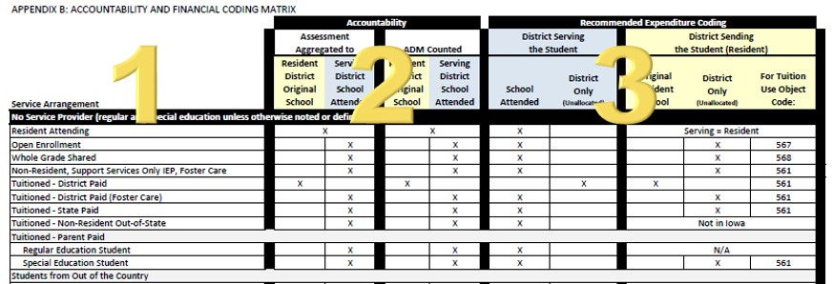

The matrix was created to provide districts with assistance in determining where expenditures should be coded for special populations so that, when possible, expenditures are coded to the district that holds accountability for the student. Once a service arrangement is determined, each district (resident and serving) will be able to identify which district will receive credit for the assessment, at which district the ADM will be assigned, and where (for both districts) the related expenditure should be coded.

Section (1): Service Arrangement

There are a number of enrollment types to be considered when determining where the accountability lies and how the expenditure should be coded. In this document, these different Service Arrangements are organized by No Service Provider and Service Provider. Within each heading, a number of enrollment types exist, some with additional sub-headings. The first step to use this matrix is to identify the appropriate service arrangement.

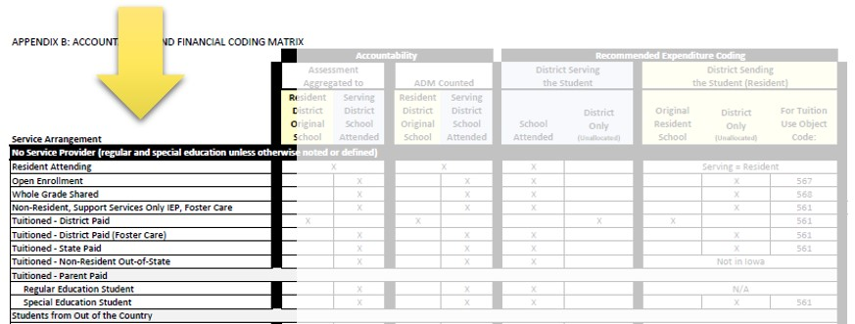

Section (2): Accountability

This section of the matrix illustrates two measures of the district’s accountability: (A) the district where the assessment is counted and (B) the district where the ADM is counted. The heading “Resident District Original School” is the equivalent of the school where the student would attend had they stayed in their resident district. The heading “Serving District School Attended” is interpreted as the school at which the student was actually served. An “x” at the intersection of the service agreement and the accountability type identifies the accountable district.

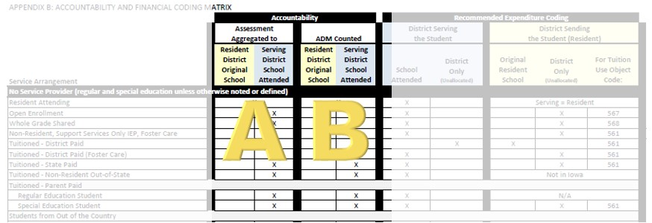

Section (3): Recommended Expenditure Coding

The final section of the matrix helps the serving and resident district determine the facility code to which related expenditures, if any, would be coded. Under the heading (A) “District Serving the Student”, the coding options are either to the facility code of the School Attended (where the student was actually served) or to a District Only facility code. Under the main heading (B) “District Sending the Student” (original resident district), there are also two coding options, including the facility code of the Original Resident School (the school the student would have attended if they were still served in the district) or a District Only facility code. The final column is for reference and illustrates the related tuition Object Code, if applicable. An “x” at the intersection of the service arrangement and the recommended expenditure coding indicates where the expenditure should be coded.

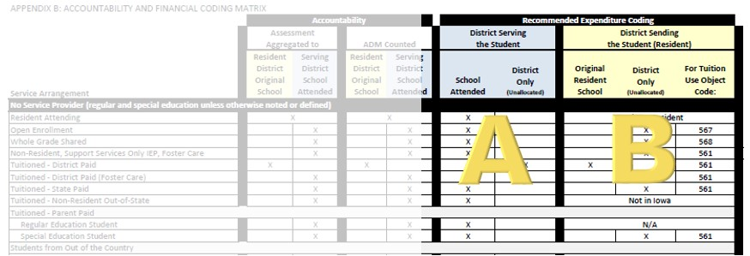

Scenarios

Scenario (1): The serving district elects to send a student to another district to be educated (Service Arrangement: Tuitioned – District Paid). Under the Accountability section, it is reflected the (1) Assessment and (2) ADM will be counted at the Resident District Original School. Under the Recommended Expenditure Coding section, (3) the District Serving the Student will code related expenditures to a district only facility code. The District Sending the Student will code related expenditures to the (4) Original Resident School and (5) use Object Code 561.

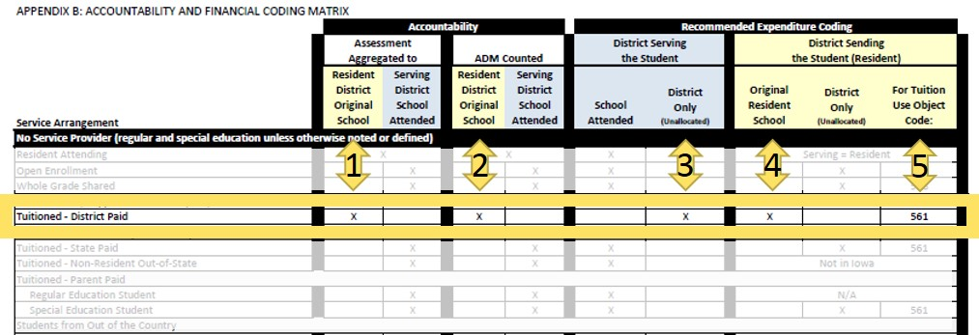

Scenario (2): A parent elects to send their special education student to another district to be educated (Service Arrangement: Tuitioned – Parent Paid, Special Education Student). Under the Accountability section, it is reflected the (1) Assessment and (2) ADM will be counted at the Serving District School Attended. Under the Recommended Expenditure Coding section, (3) the District Serving the Student will code the related expenditures to the facility code of the School Attended. The District Sending the Student (Resident) will code related expenditures at a District Only facility code and use (5) tuition Object Code 561, as appropriate.

