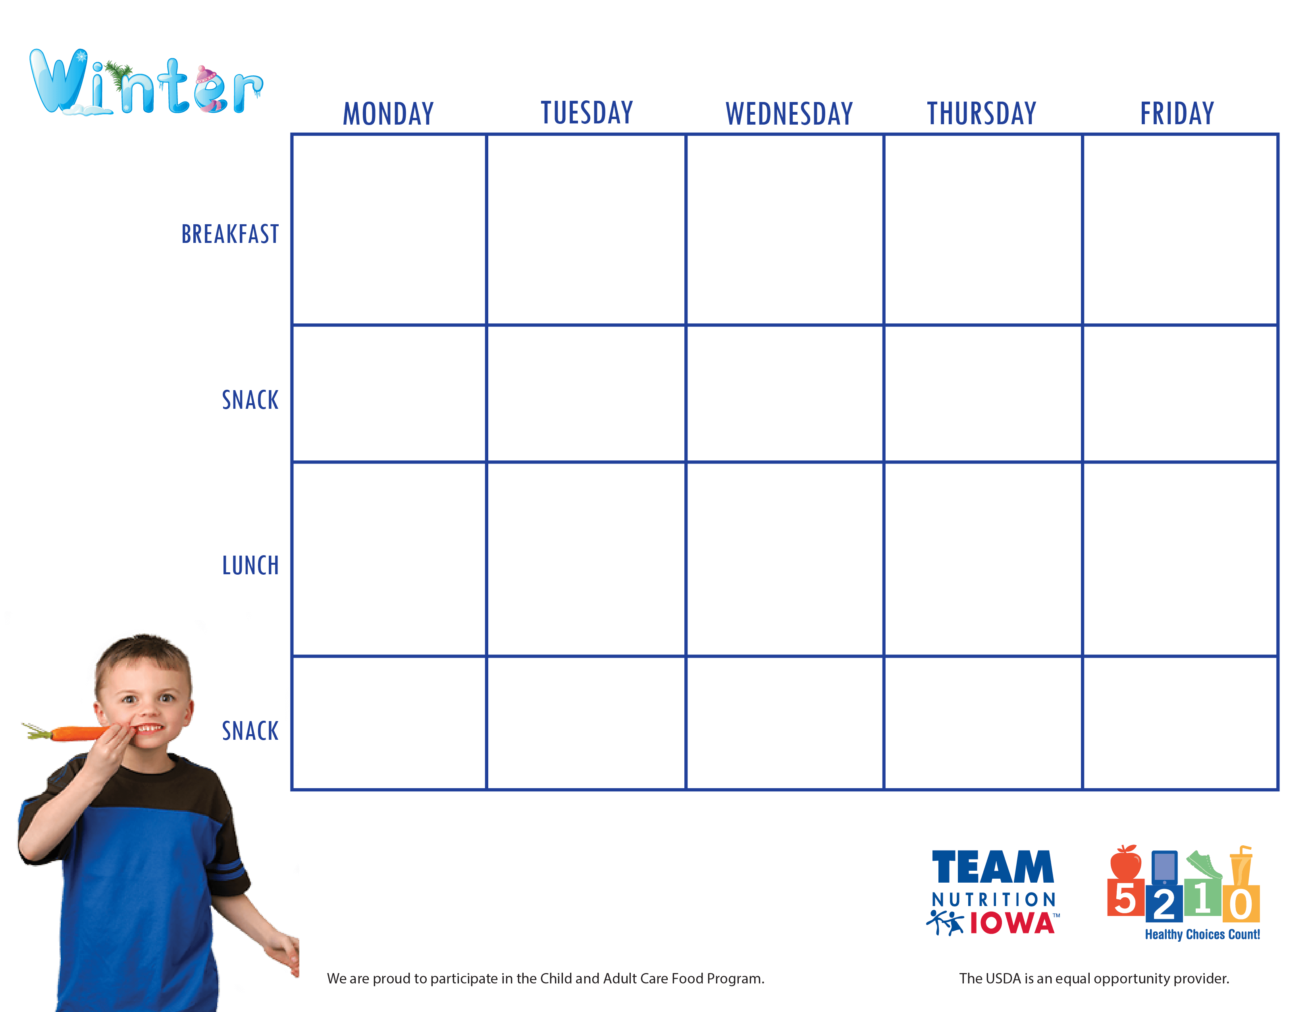

Center Name and contact information

**December 21st- 25th**