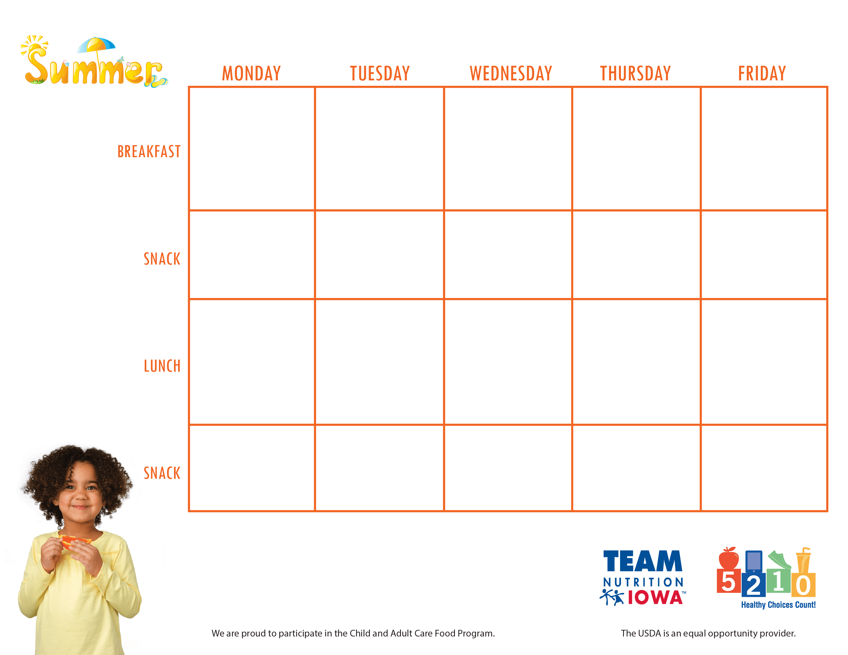

Center Name and contact information

**June 21st- 25th**