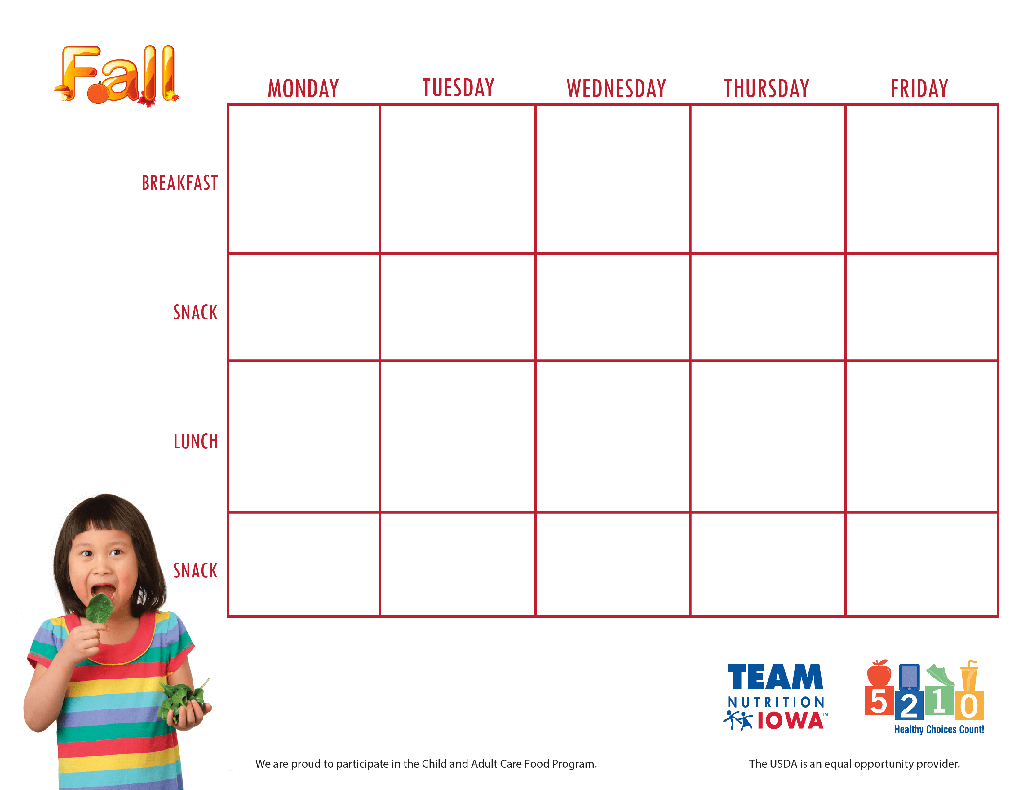

Center Nameand contact information

**September, 4th- 8th**