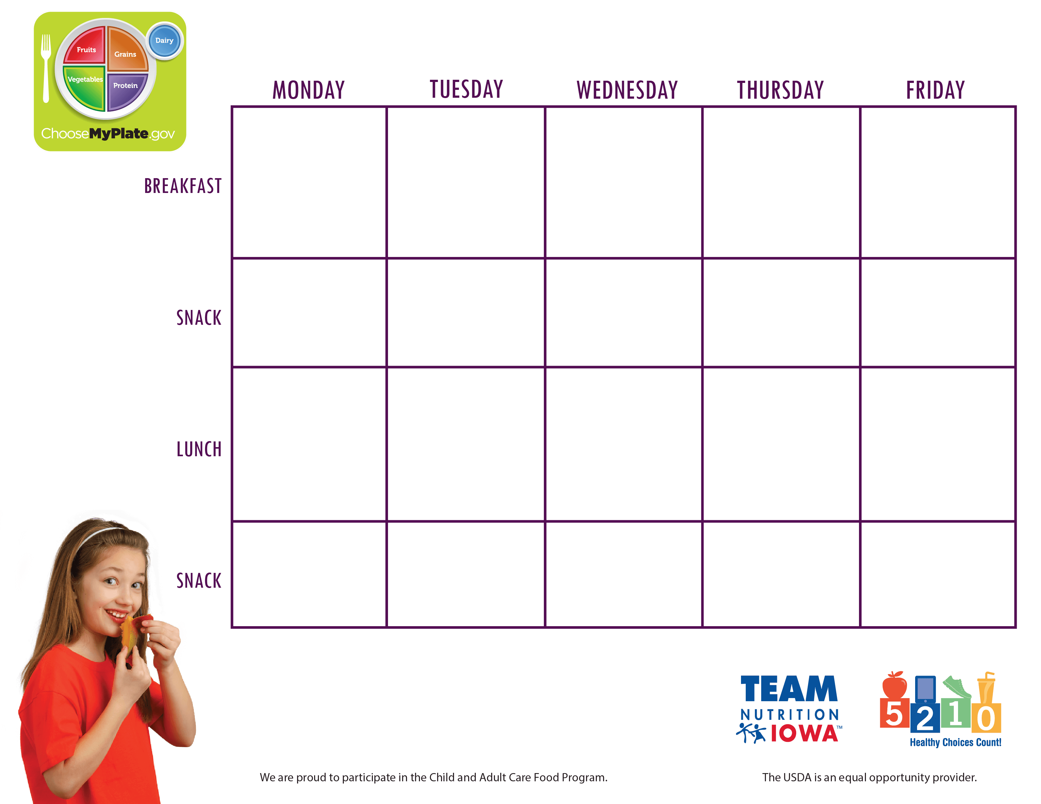

Center Name and contact information

**September, 4th- 8th**