Completing The Perkins V Performance Improvement Plan

An Eight Step Process

STEP 1 | Start with Your Performance Letter
Read both pages (printed front & back):
- Confirm the recipient’s name and the academic year being evaluated.
- The federal plan trigger concerns the eligible recipient’s overall result for the indicator;
  - The disaggregated data help explain and address the gaps.
- Plan implementation period: November 1, 2026 - October 31, 2027
Utilize the ‘hyperlinked indicator reference’ if you need help understanding what an indicator measures or which students are counted:
- Secondary: https://educate.iowa.gov/media/12453/download?inline
- Postsecondary: https://educate.iowa.gov/media/12425/download?inline
In this example, the letter reports AEA Consortium Four’s AY 2024–2025 results, not an individual member district’s result.
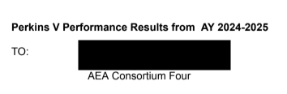
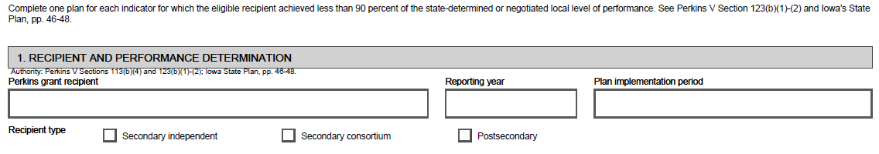
STEP 2 | Identify Indicators Requiring a Plan
Compare the AY24-25 Performance column with the AY24-25 90% of Target column, then check the Indicator of Performance Met (Y/N) column.
The threshold is 90 percent of the approved target, not a requirement that every indicator’s actual result reach 90 percent.
Examples from the “AEA Consortium Four’s AY 2024–2025 results” letter:
Indicator of Performance | AY 24-25 Target | AY 24-25 90% of Target | AY 24-25 Performance | Indicator of Performance Met (Y/N)
2S1: Academic Proficiency in ELA | 69.38% | 62.44% | 65.39% | YES*
2S3: Academic Proficiency in Science | 65.86% | 59.27% | 56.87% | NO
4S1: Non-traditional Program Concentration | 27.19% | 24.47% | 24.36% | NO
*ELA illustrates an important distinction: the recipient was below the full target but above the 90-percent threshold. However, under this letter, 2S3: Academic Proficiency in Science and 4S1: Non-traditional Program Concentration require plans.
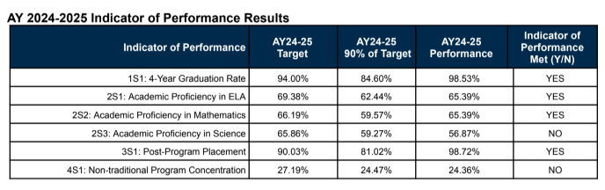
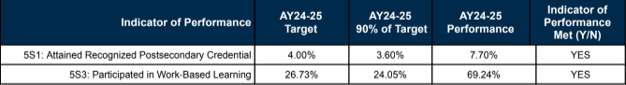

STEP 3 | Complete One Form for Each “NO”
Following the letter’s instructions, AEA Consortium Four would complete (2) forms:
- One form for 2S3: Academic Proficiency in Science
- One form for 4S1: Non-traditional Program Concentration
In Section 1 of each form:
- Enter the recipient,
- Reporting year,
- Implementation period,
- Recipient type,
- Indicator of performance,
- 2024-2025 target,
- 2024-2025 90% threshold, and
- AY22024-2025 actual performance result/outcome
- Copy the results from the letter.
Keep the evaluation year separate from the period when improvement activities will occur.
Performance Improvement Plan
If a performance indicator listed in this report did not meet at least 90% of the target, please submit one plan
form for each unmet indicator target to jeffreyfletcher@iowa.gov. The deadline to return is October 31, 2026.
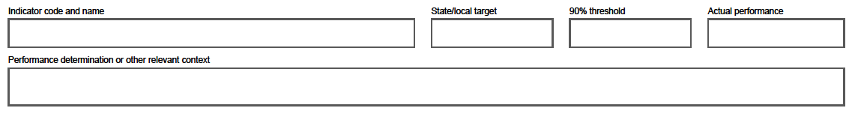

STEP 4 | Analyze the Overall Result
- Use the dashboard and public-results spreadsheet linked in the letter.
- Review the 2024-2025 AY reporting year and examine available results by participating district, student population, CTE program, and/or program area(s).
- Summarize the findings in Section 2.
For a consortium, start with the consortium-level determination, then use member-district data to identify where action is needed.
Reminder: The federal plan trigger concerns the eligible recipient’s overall result for the indicator;
- The disaggregated data help explain and address the gaps.
For secondary consortiums (and independent recipients) not achieving 90% on a performance indicator target, please review the disaggregated performance data across each participating school district, including student population groups, by navigating to the www.iowastudentoutcomes.com dashboards.
For this data in spreadsheet form, please click on the following Public District-Level: 2024-2025AY Accountability Results hyperlink for the public-facing Google sheet file for viewing and download only.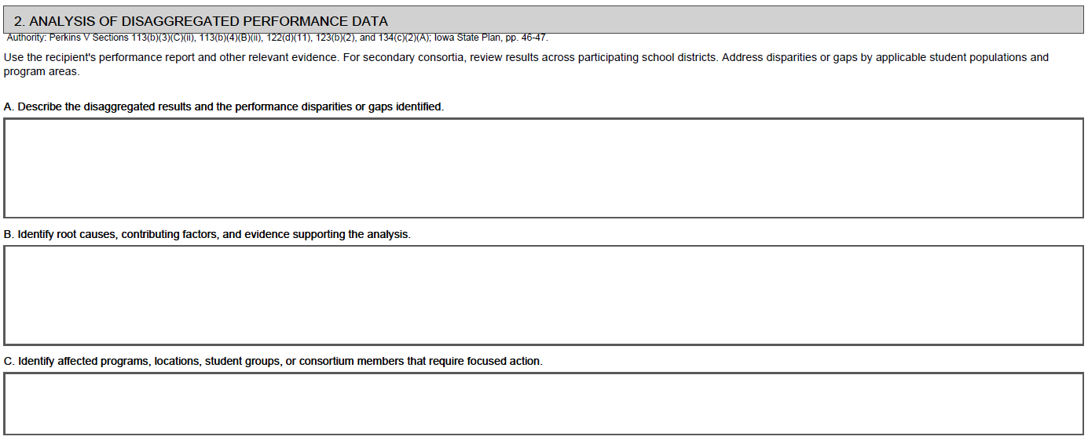

STEP 5 | Identify Likely Contributing Factors
The letter identifies what needs improvement—not why.
- Work with relevant staff and stakeholders to identify contributing factors.
- Use local evidence, student feedback, the Comprehensive Local Needs Assessment (CLNA), local Perkins V grant applications (current and/or prior)..
- Document the evidence behind your explanation, and distinguish confirmed findings from possibilities that require more investigation.
- Record the contributing factors in Section 2, and the stakeholder involvement in Section 4
STEP 6 | Identify Actions and Assign Responsibility
Complete Section 3 by answering (4) questions for each action:
- Choose actions that address the contributing factors you identified.
- Connect them to the CLNA and local planning.
“Improve science performance” is a goal— not an action.
For each action, specify:
- What will we do?
- Who is responsible?
- When will it happen?
- What evidence will show progress?
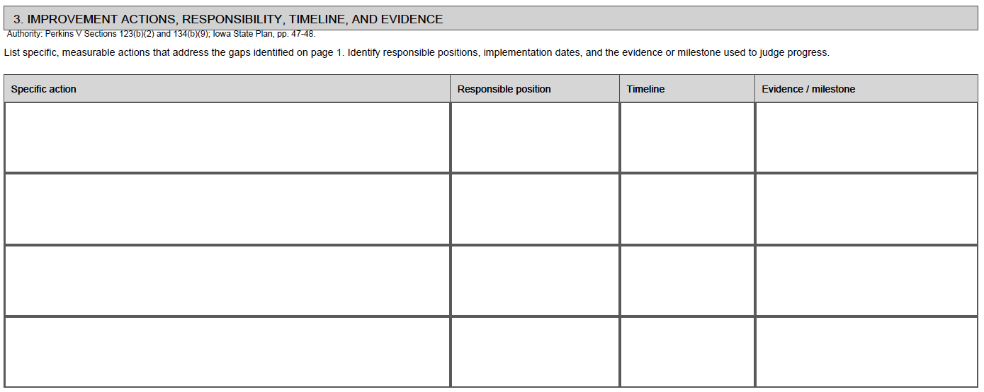
STEP 7 | Monitor Progress and Identify Support Needs
In Section 4, identify how often the team will review progress, what information it will examine, and what success will look like.
- Check both whether the activities occurred and whether learners are benefiting.
- Identify whether any Iowa Department of Education technical assistance is necessary and/or will be pursued, as well as document how stakeholder input shaped the plan.
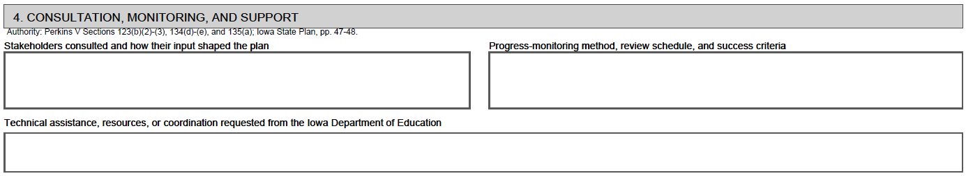
STEP 8 | Finalize, Submit, and Implement
Electronic signatures are acceptable.
- Complete the assurances,
- Obtain the Perkins coordinator and administrator signatures, and
- Leave the CTE Bureau signature “blank/empty” for Department review.
- Page 3 provides citations and references; it does not require responses.
- For the attached AY 2024–2025 letter, submit each completed plan by October 31, 2026.
- Send submissions and/or accountability questions to jeffrey.fletcher@iowa.gov & cale.hutchings@iowa.gov, the addresses listed in the letter’s contact section.
- Keep a local copy and follow the implementation and progress-review schedule documented in the plan.
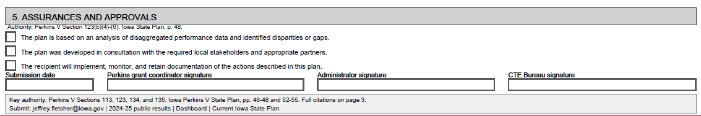

Citations and Source Guide
